**CSE434 Lab 1 Report**

**Group 82**

**Group Members:**

**Jeet Thakkar**

**Wei Hng Yeo**

**Exercise 1**

Step 1

Running the command: ifconfig -a

The IP address is shown below (indicated in red).

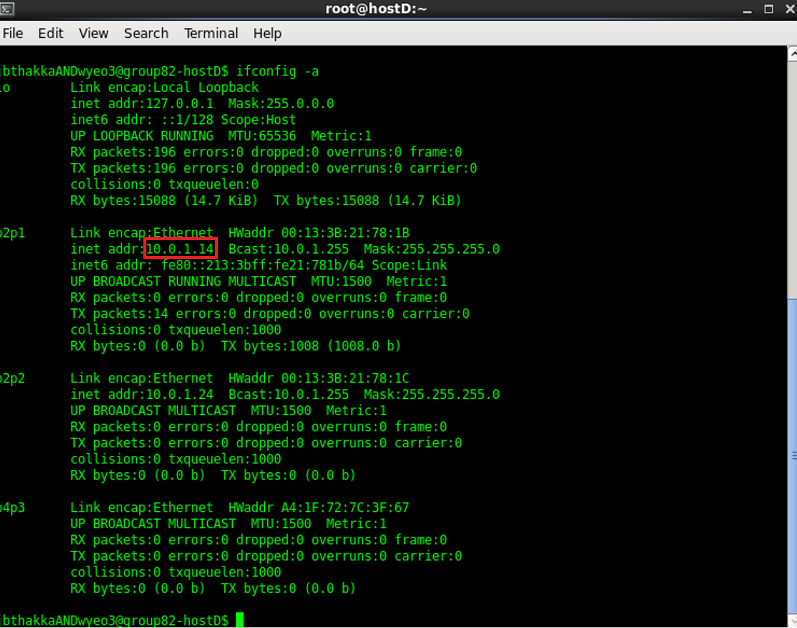

Step 2

Running the command: ifconfig p2p1 10.0.1.16 netmask 255.255.255.0 broadcast 10.0.1.255

Step 3

Running the command: ifconfig -a

The IP address has been changed from 10.0.1.14 to 10.0.1.16 (indicated in red).

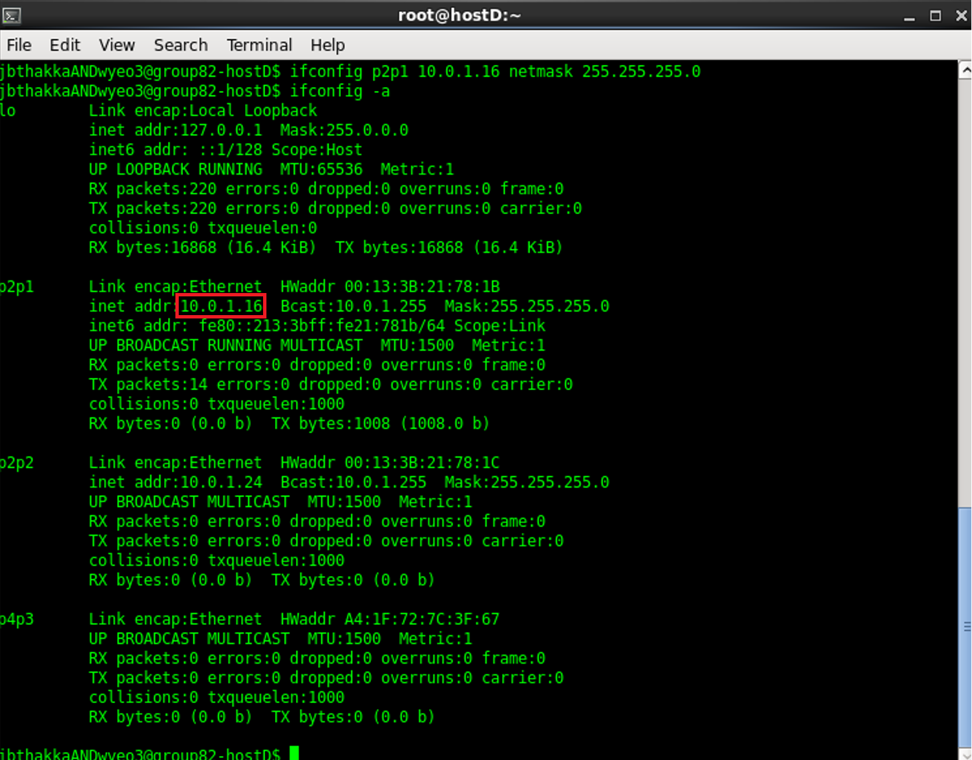

**Exercise 2**

Step 1

Commands used in the following computer to configure the IP address are shown below.

Computer A: ifconfig 128.143.71.201 netmask 255.255.0.0

Computer B: ifconfig 128.143.71.21 netmask 255.255.255.0

Computer C: ifconfig 128.143.137.144 netmask 255.255.255.192

Computer D: ifconfig 128.143.137.32 netmask 255.255.255.192

Step 2

(a)

From terminal:

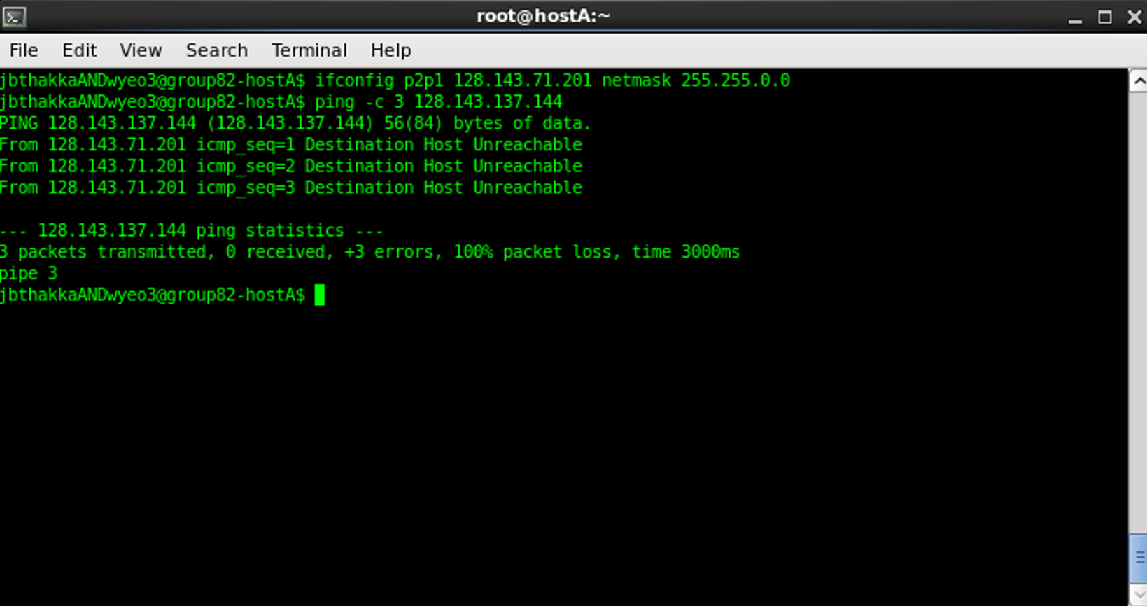

From Wireshark:

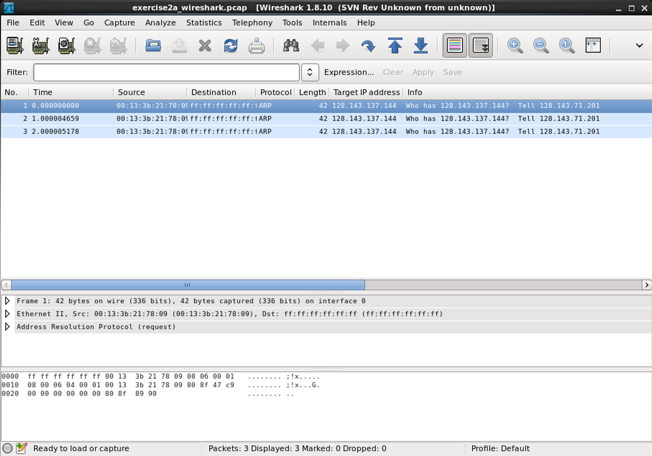

(b)

From Terminal:

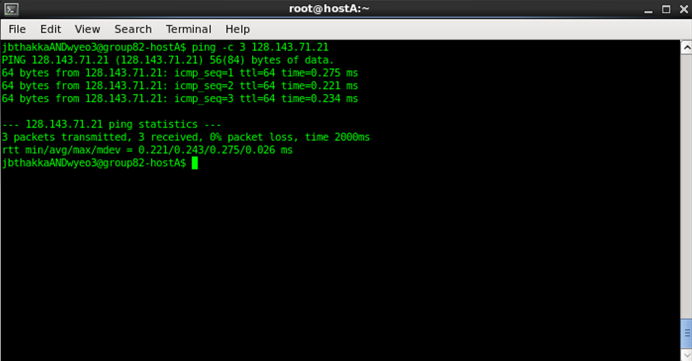

From Wireshark:

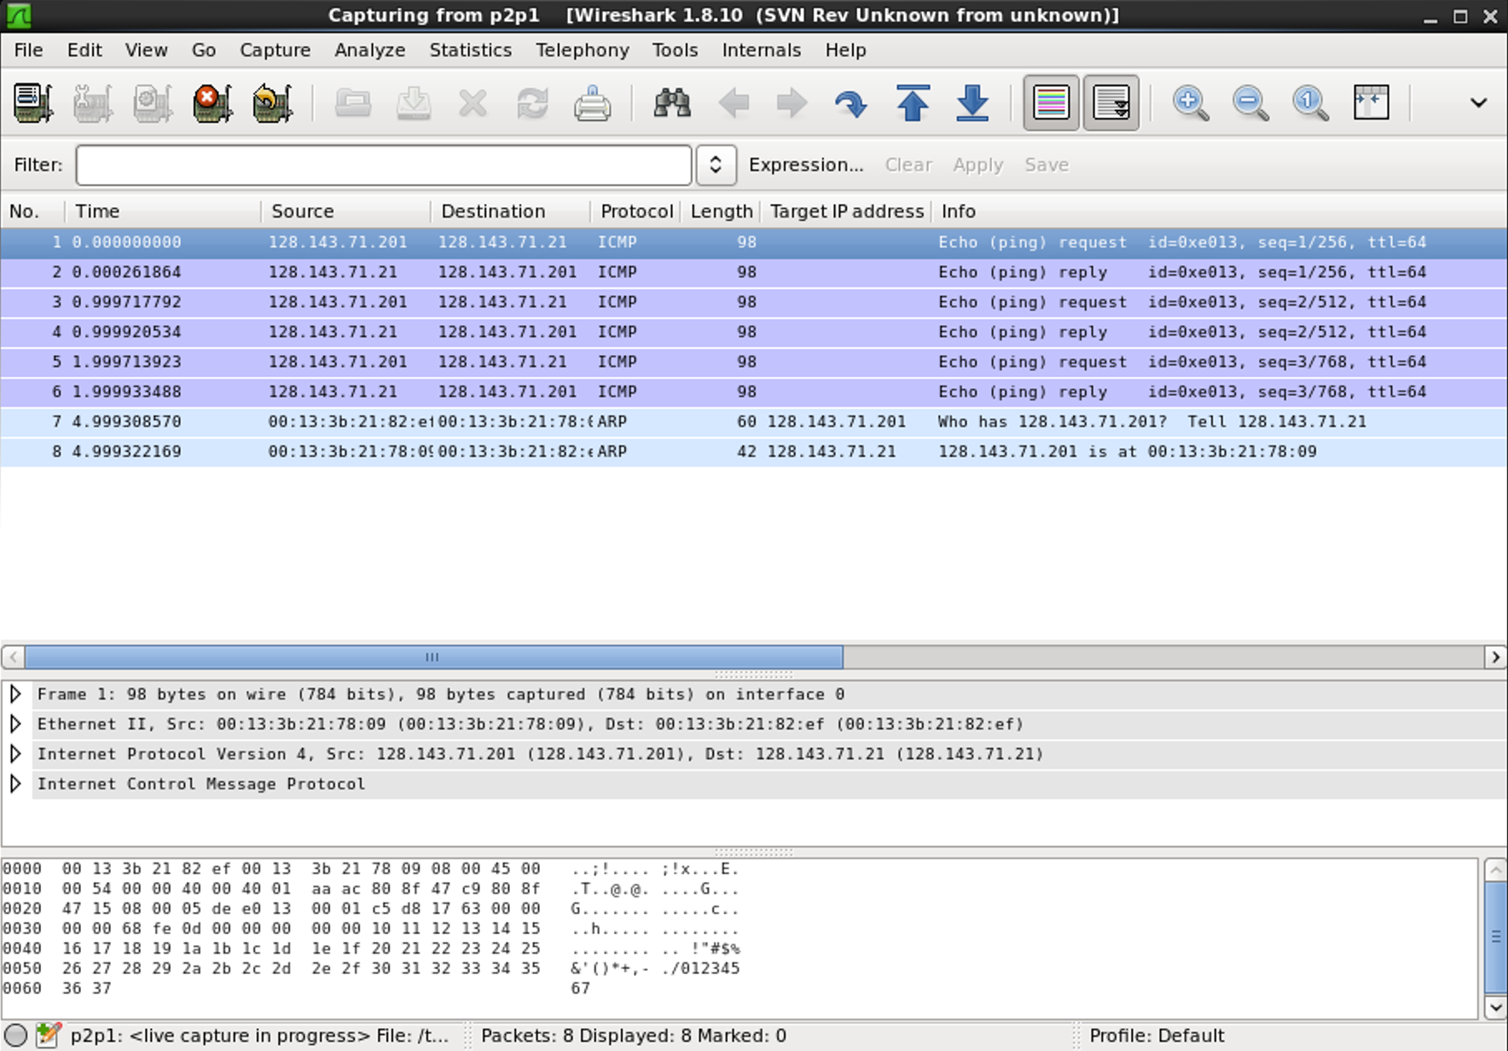

(c)

From Terminal:

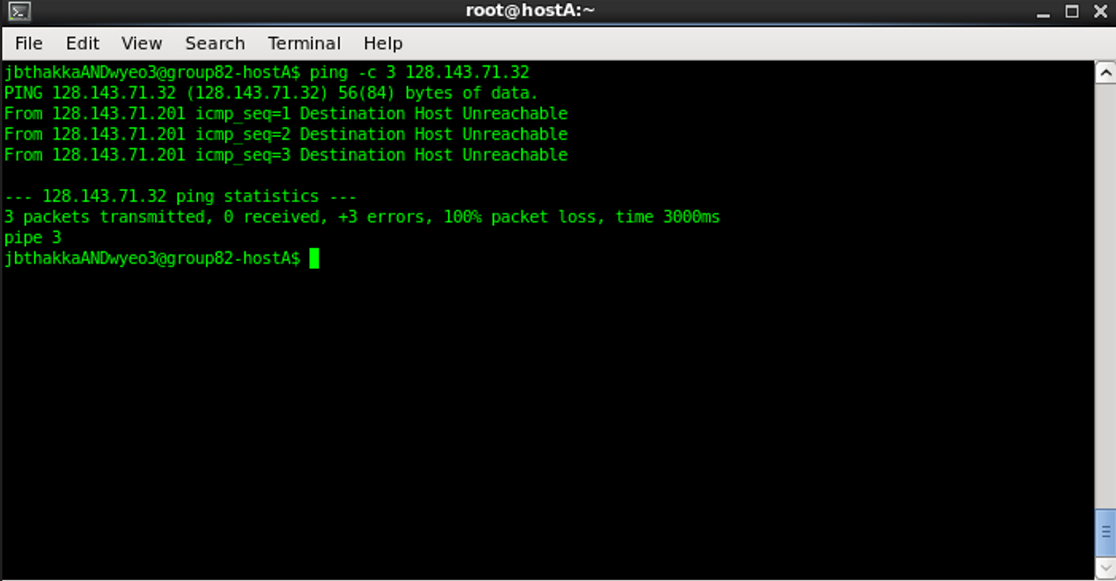

From Wireshark:

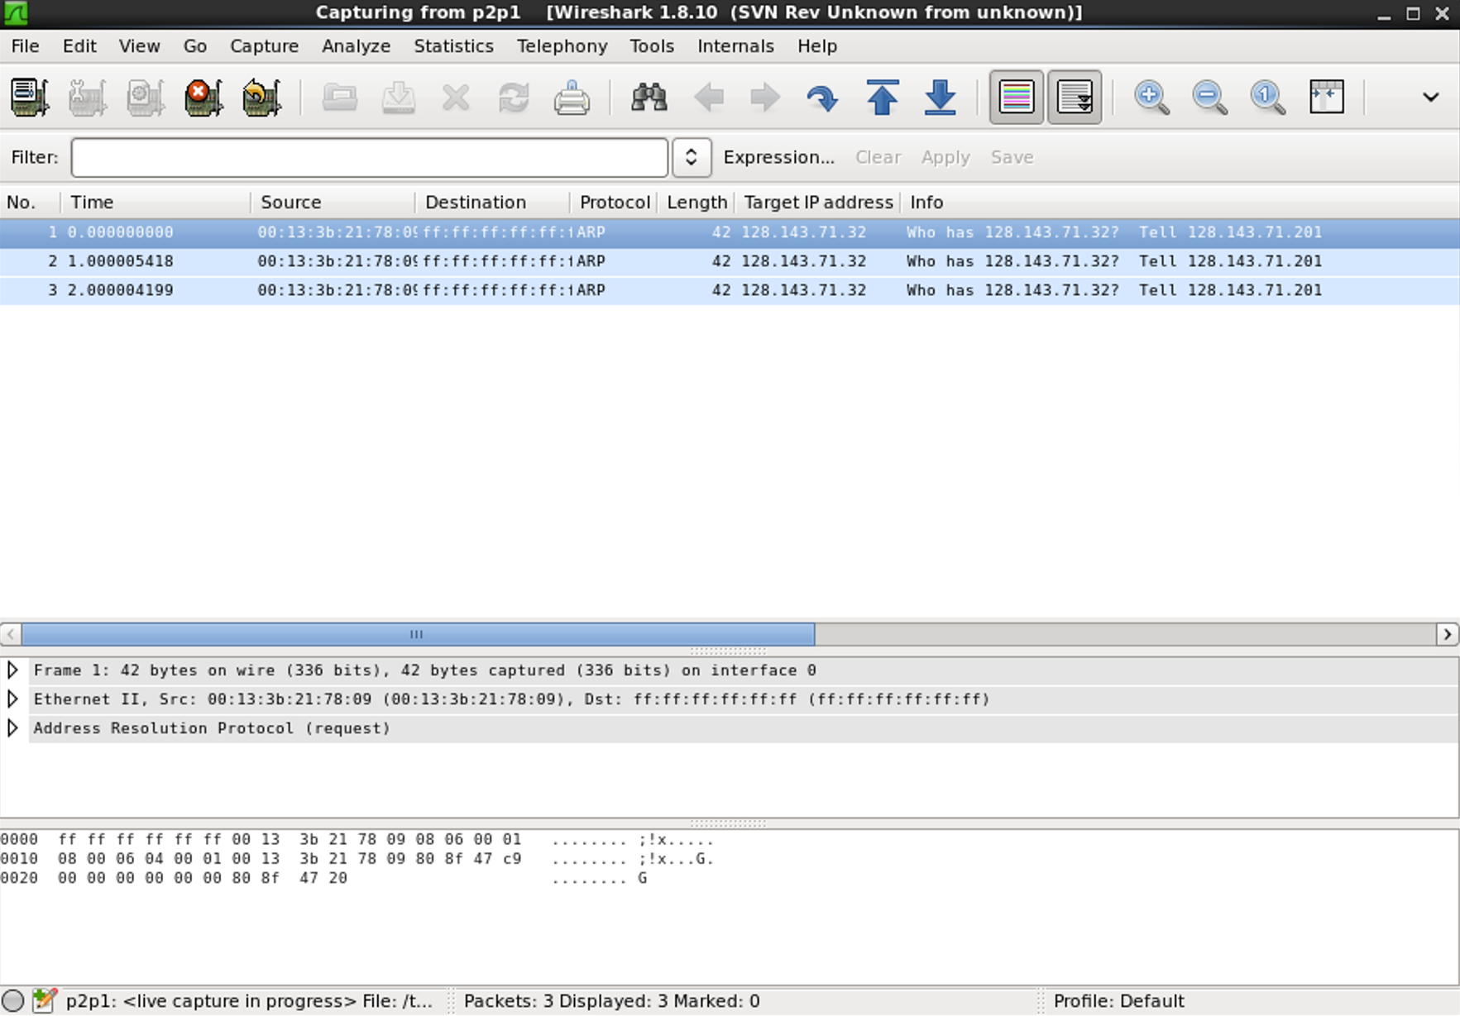

(d)

From Terminal:

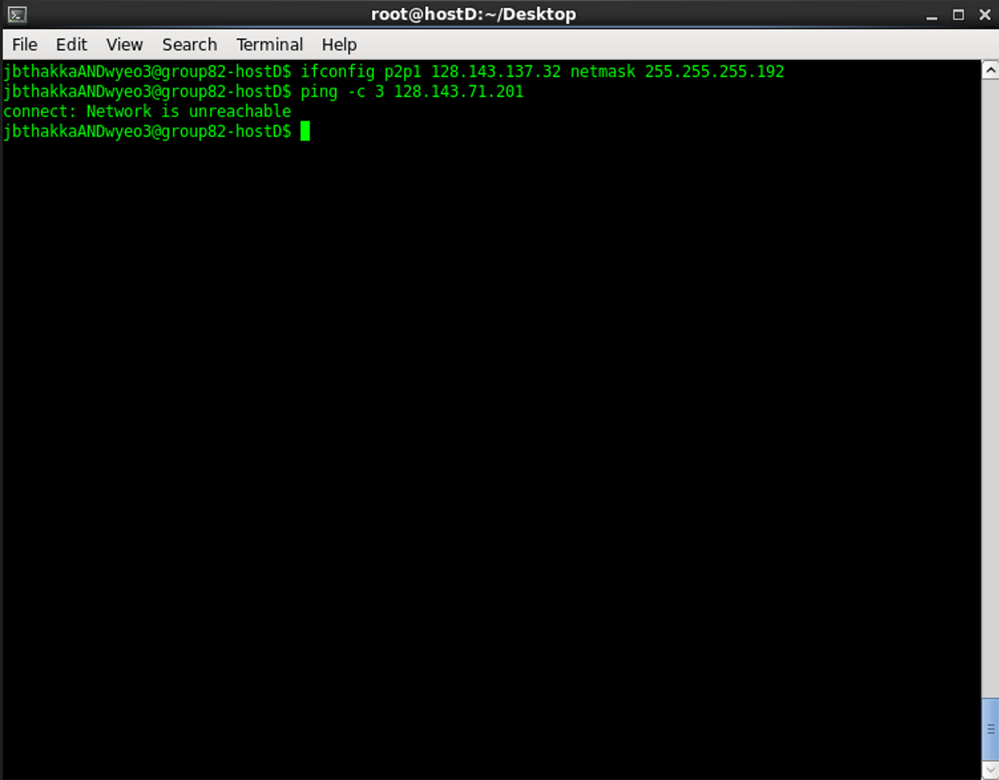

From Wireshark:

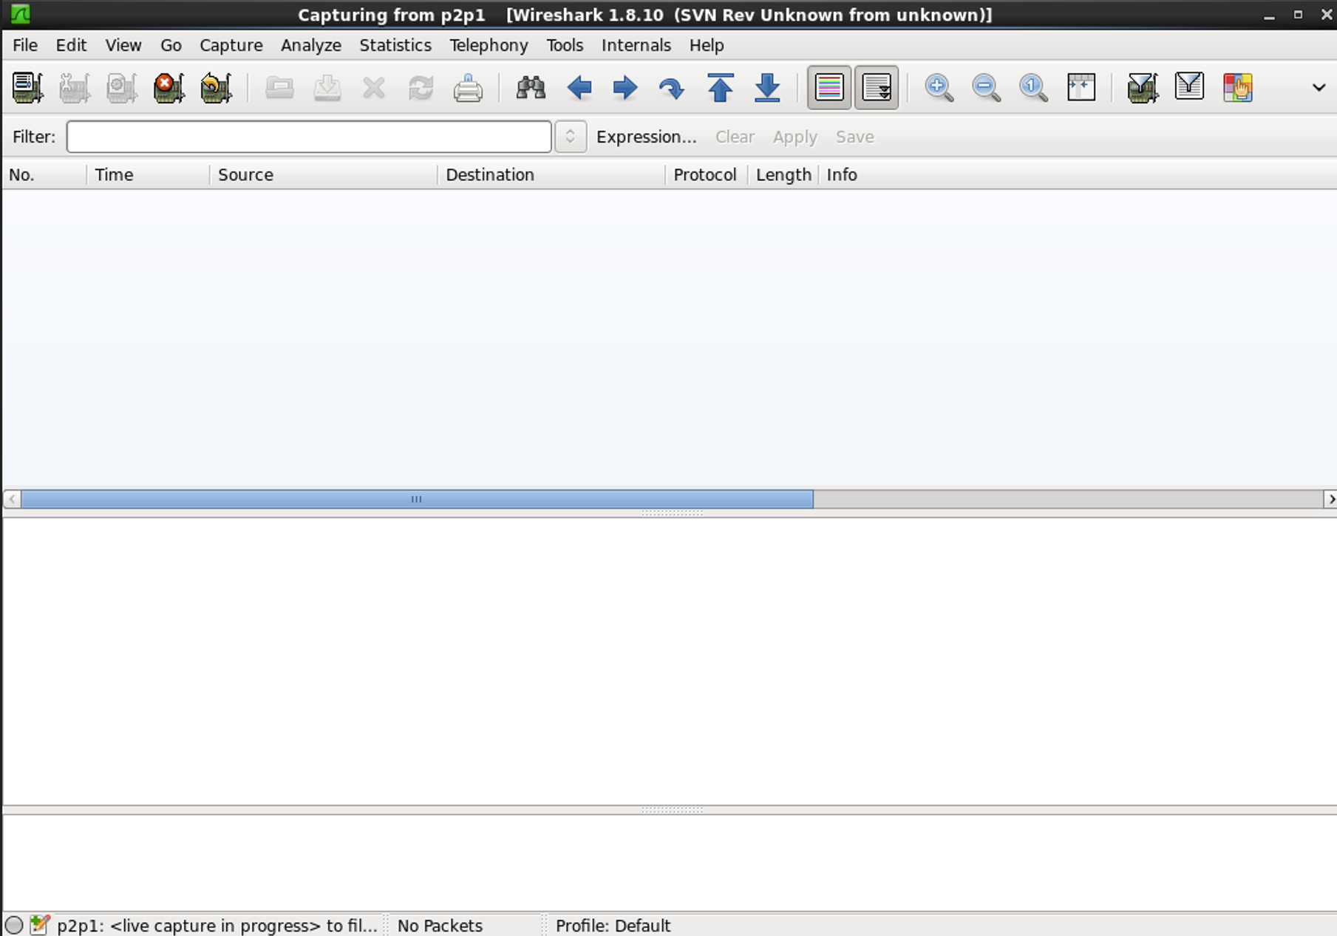

(e)

From Terminal:

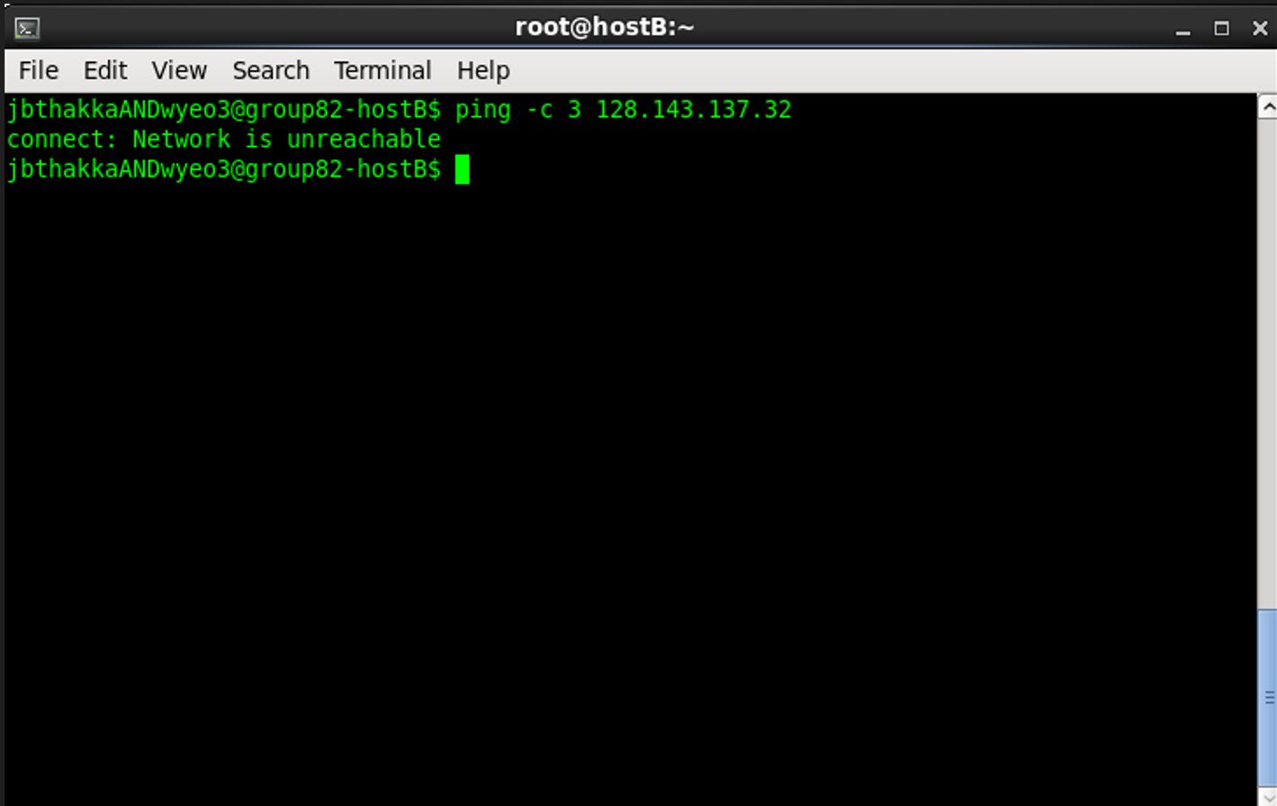

From Wireshark:

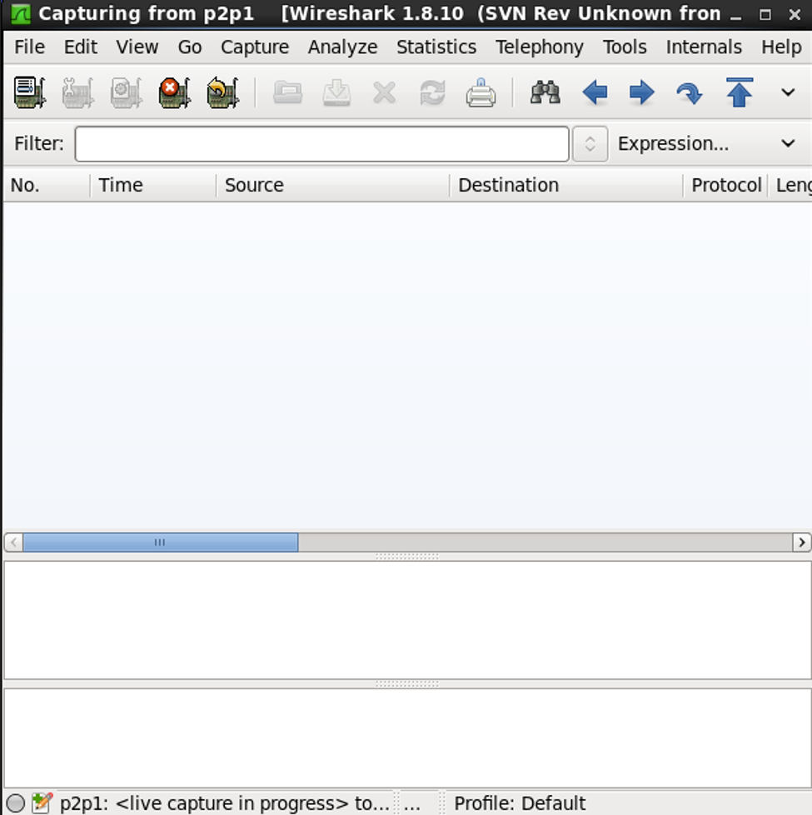

(f)

From Terminal:

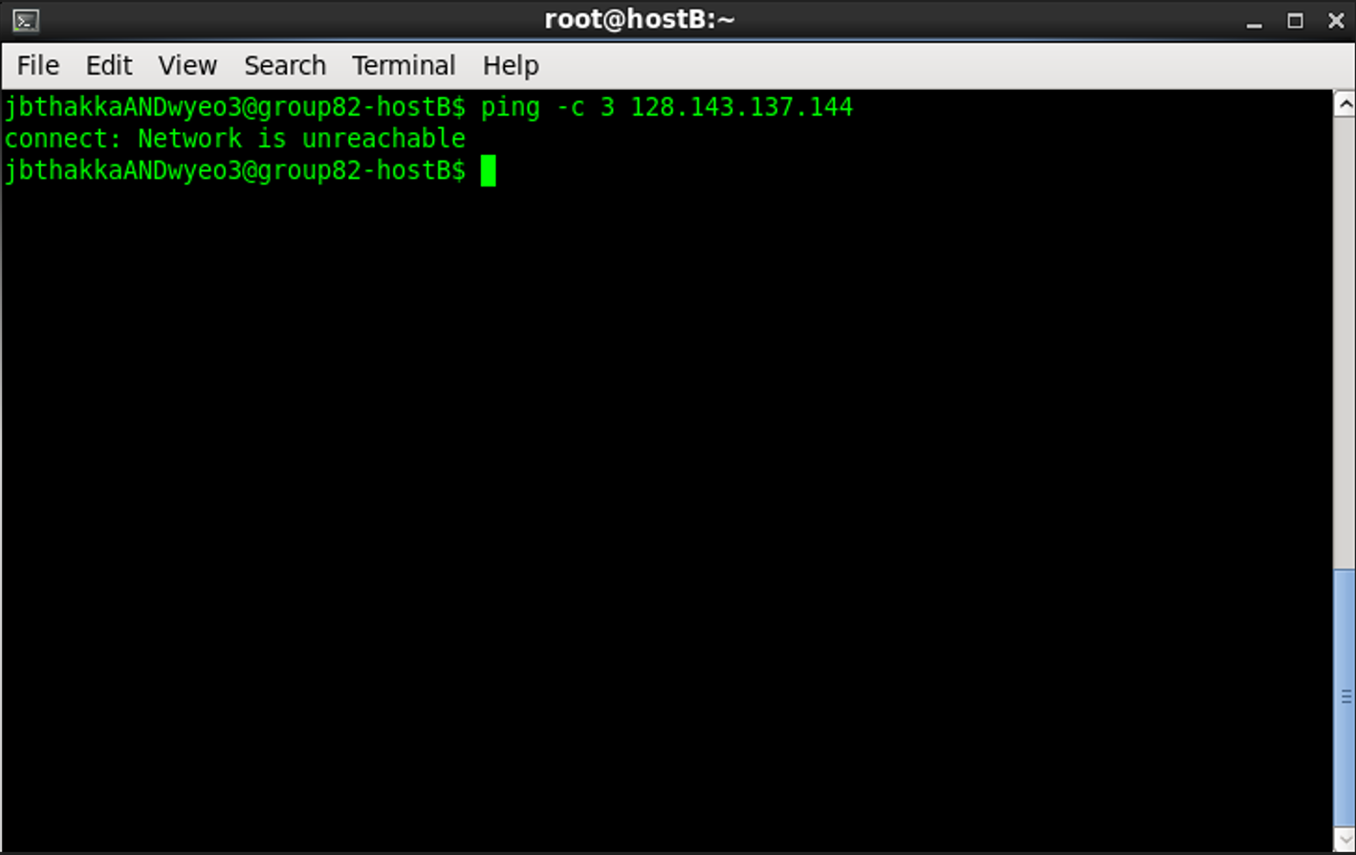

From Wireshark:

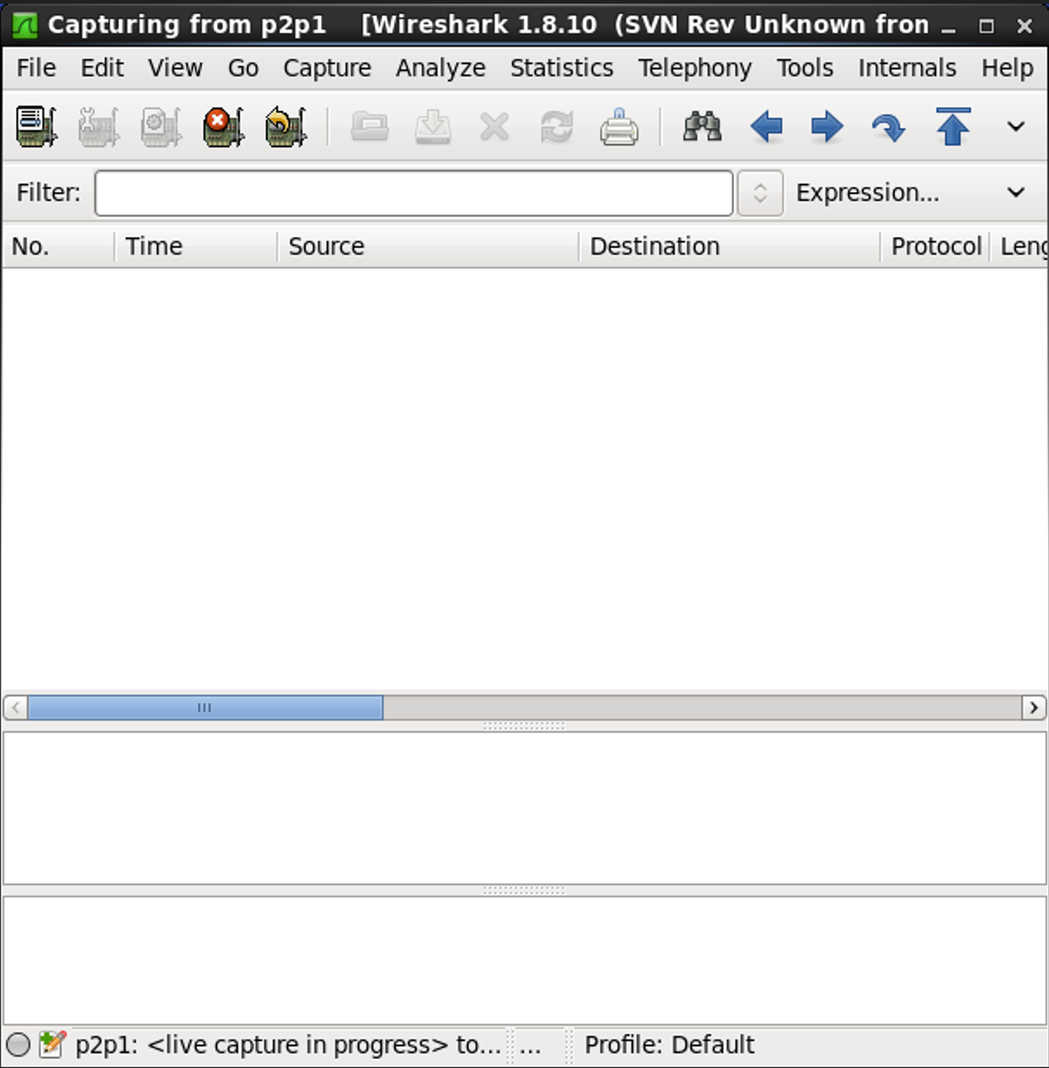

**Exercise 3**

Step 1: Topology View

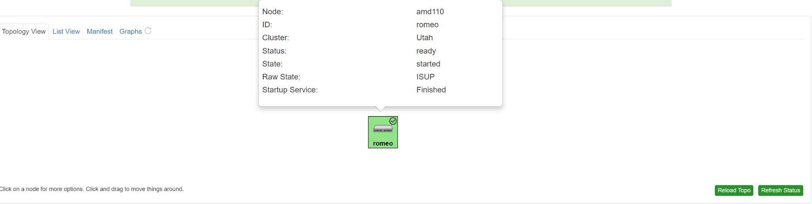

Step 2: Terminal Echo

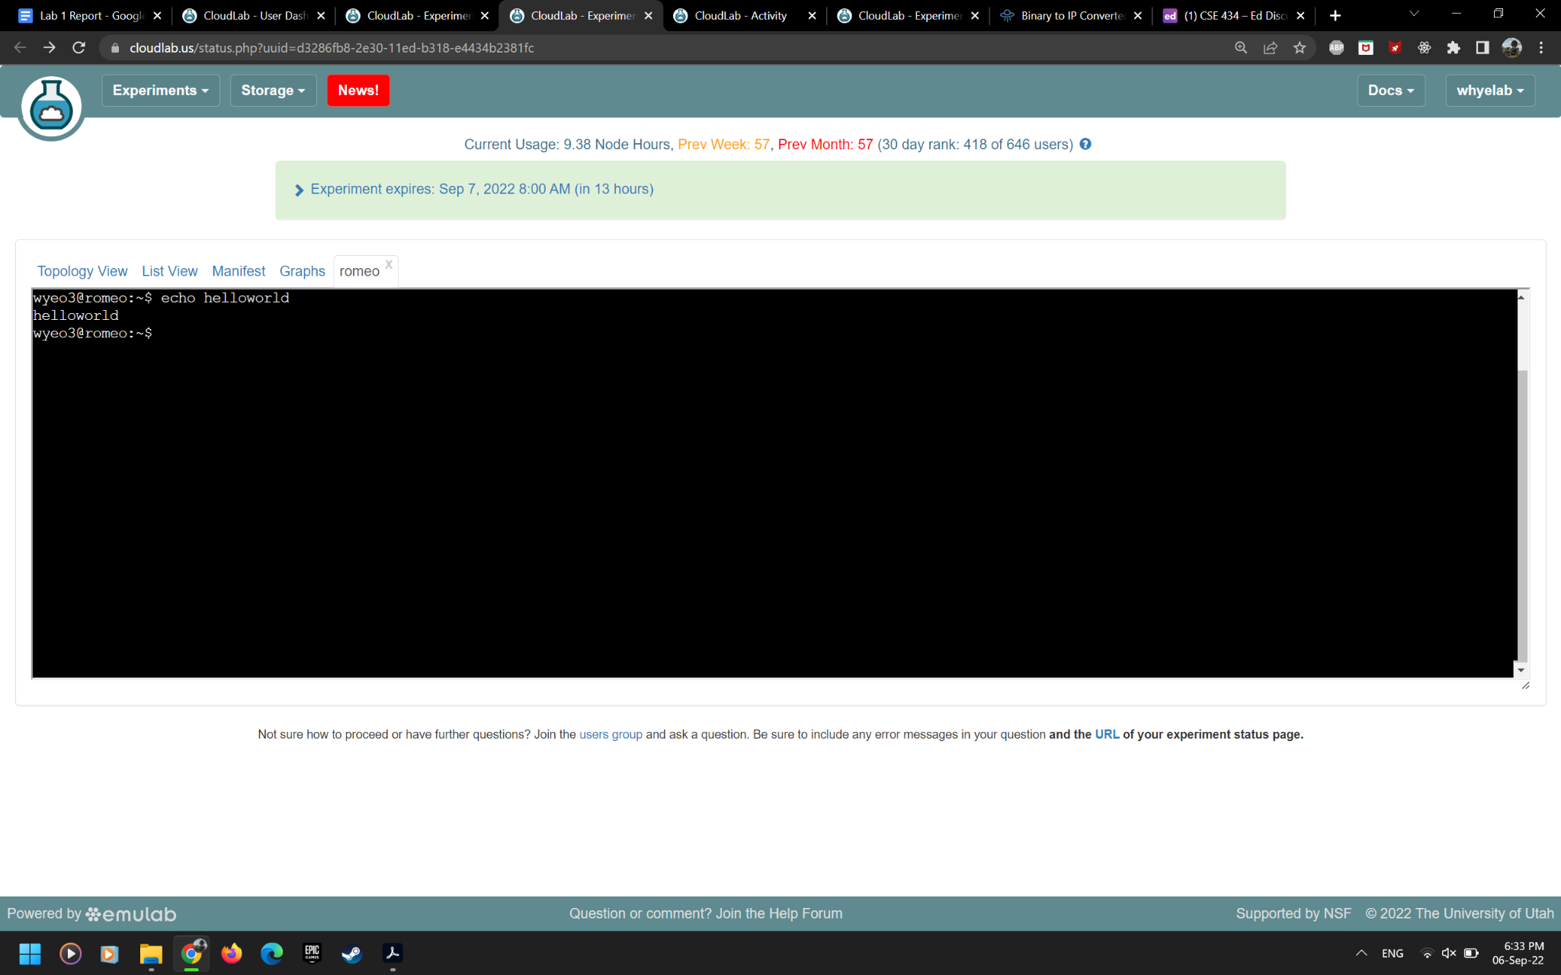

Step 3: Connecting via Terminal and VNC View

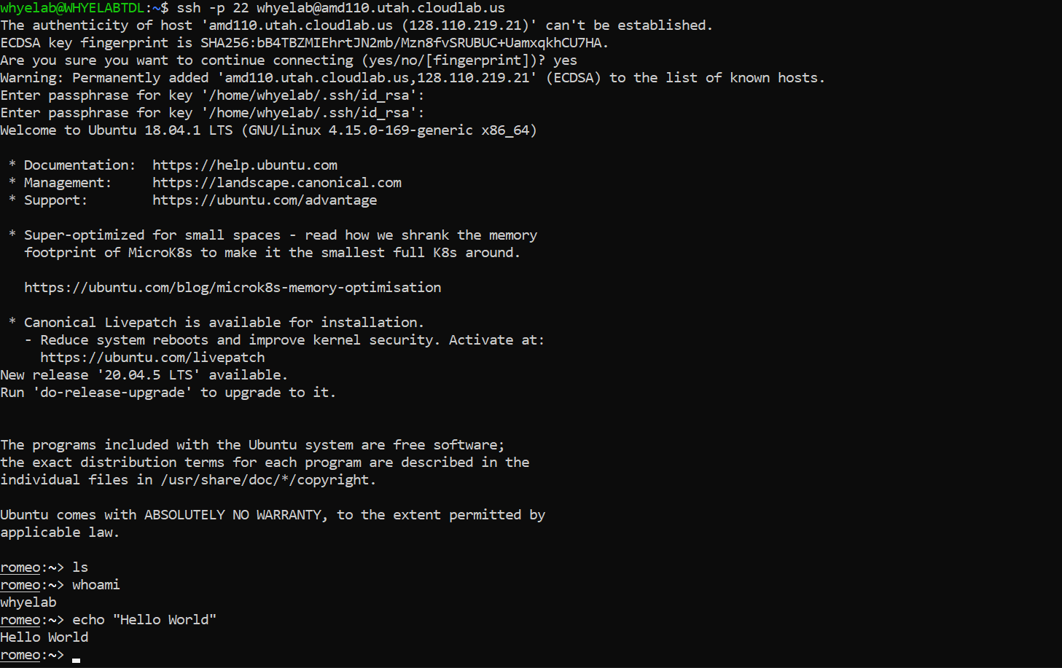

Connection via Terminal

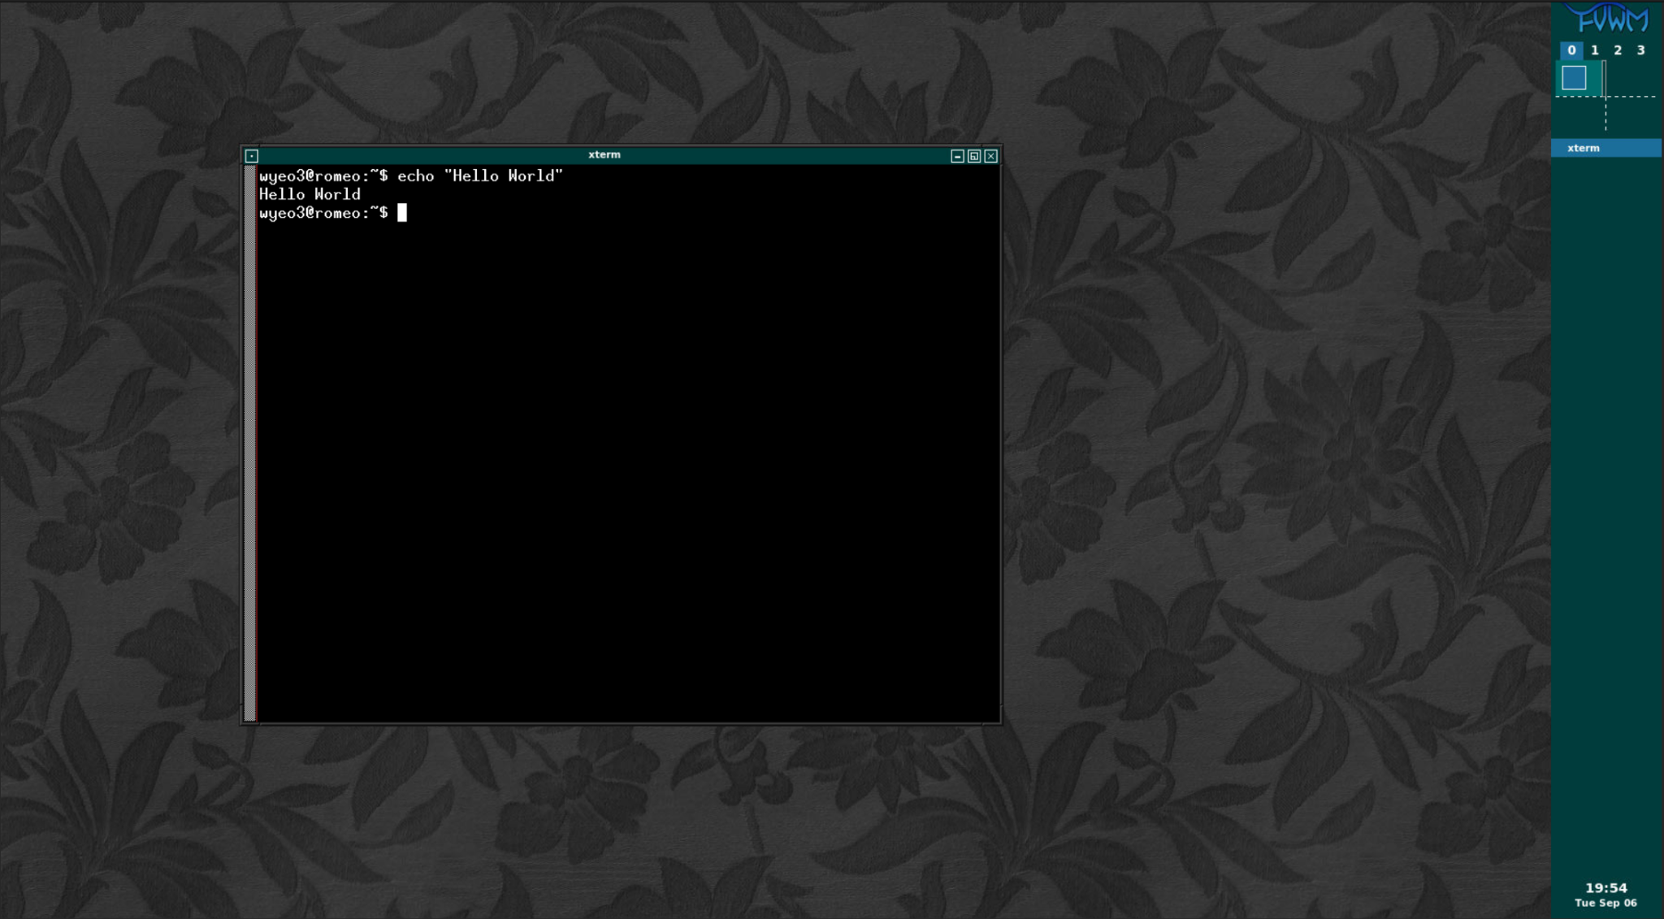

VNC view

**Exercise 4**

|  |  |  |  |  |  |  |
| --- | --- | --- | --- | --- | --- | --- |
| Hosts | Subnet Mask | Network Address | Smallest Host Address | Highest Host Address | Broadcast Address | Notes |
| LAN A:  romeo and  juliet | 255.255.255.192 | 10.10.172.128 | 10.10.172.130 | 10.10.172.190 | 10.10.172.191 | Should  support at  least 50  hosts |
| LAN B:  othello and  desdemona | 255.255.255.128 | 10.10.172.0 | 10.10.172.2 | 10.10.172.126 | 10.10.172.127 | Should  support at  least 75  hosts |
| LAN C:  hamlet and  ophelia | 255.255.255.224 | 10.10.172.192 | 10.10.10.194 | 10.10.172.222 | 10.10.172.223 | Should  support at  least 20  hosts |

**Exercise 5**

Commands

router-a: sudo ifconfig eth2 10.10.172.129 netmask 255.255.255.192 broadcast 10.10.172.191

romeo: sudo ifconfig eth1 10.10.172.130 netmask 255.255.255.192 broadcast 10.10.172.191

juliet: sudo ifconfig eth1 10.10.172.131 netmask 255.255.255.192 broadcast 10.10.172.191

router-b: sudo ifconfig eth2 10.10.172.1 netmask 255.255.255.128 broadcast 10.10.172.127

othello: sudo ifconfig eth1 10.10.172.2 netmask 255.255.255.128 broadcast 10.10.172.127

desdemona: sudo ifconfig eth1 10.10.172.3 netmask 255.255.255.128 broadcast 10.10.172.127

router-c: sudo ifconfig eth2 10.10.172.193 netmask 255.255.255.224 broadcast 10.10.172.223

ophelia: sudo ifconfig eth1 10.10.172.194 netmask 255.255.255.224 broadcast 10.10.172.223

hamlet: sudo ifconfig eth1 10.10.172.195 netmask 255.255.255.224 broadcast 10.10.172.223

Step 1 (LAN A between romeo & juliet):

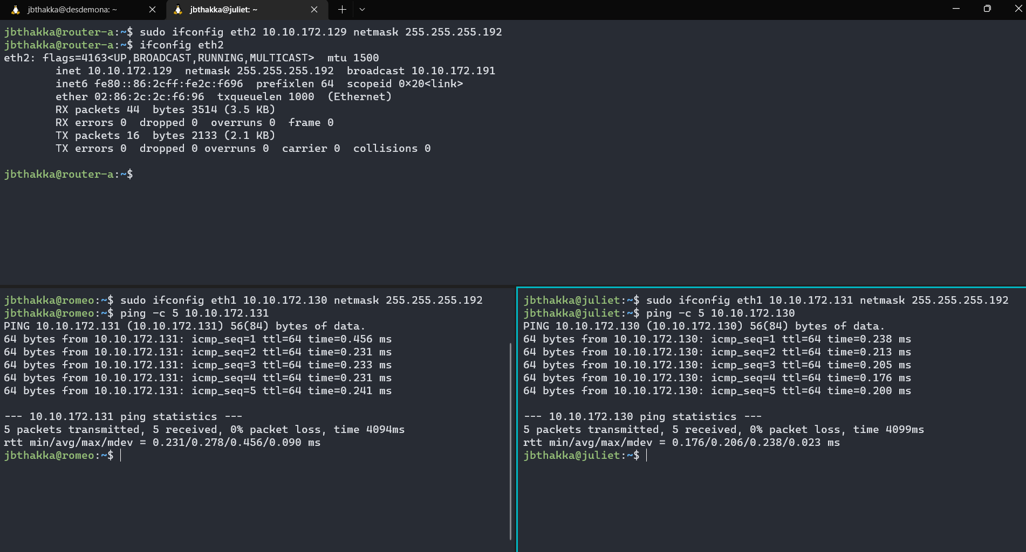

Step 1 (LAN B between desdemona & othello):

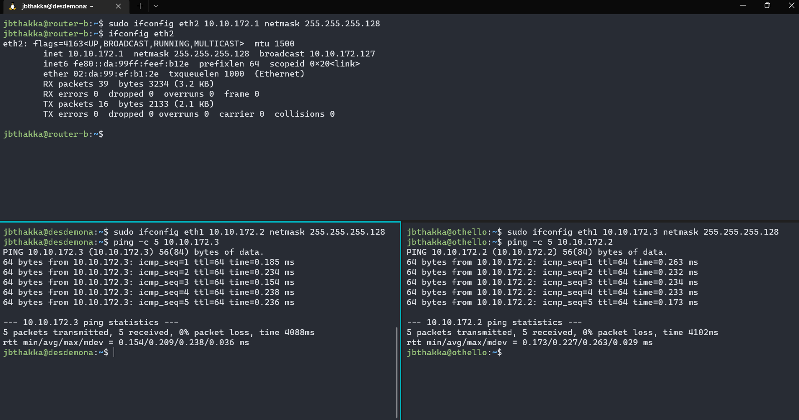

Step 1 (LAN C between ophelia & hamlet):

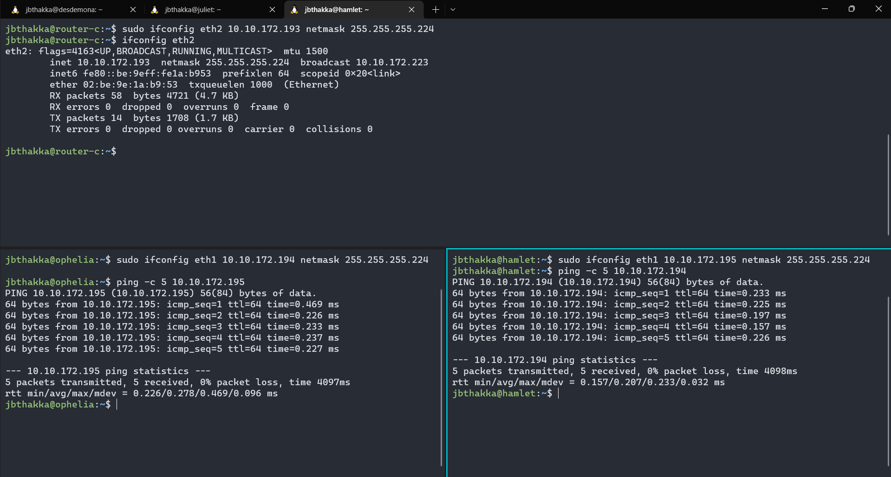

Step 2 Ping from LAN A (romeo) To LAN B (desdemona):

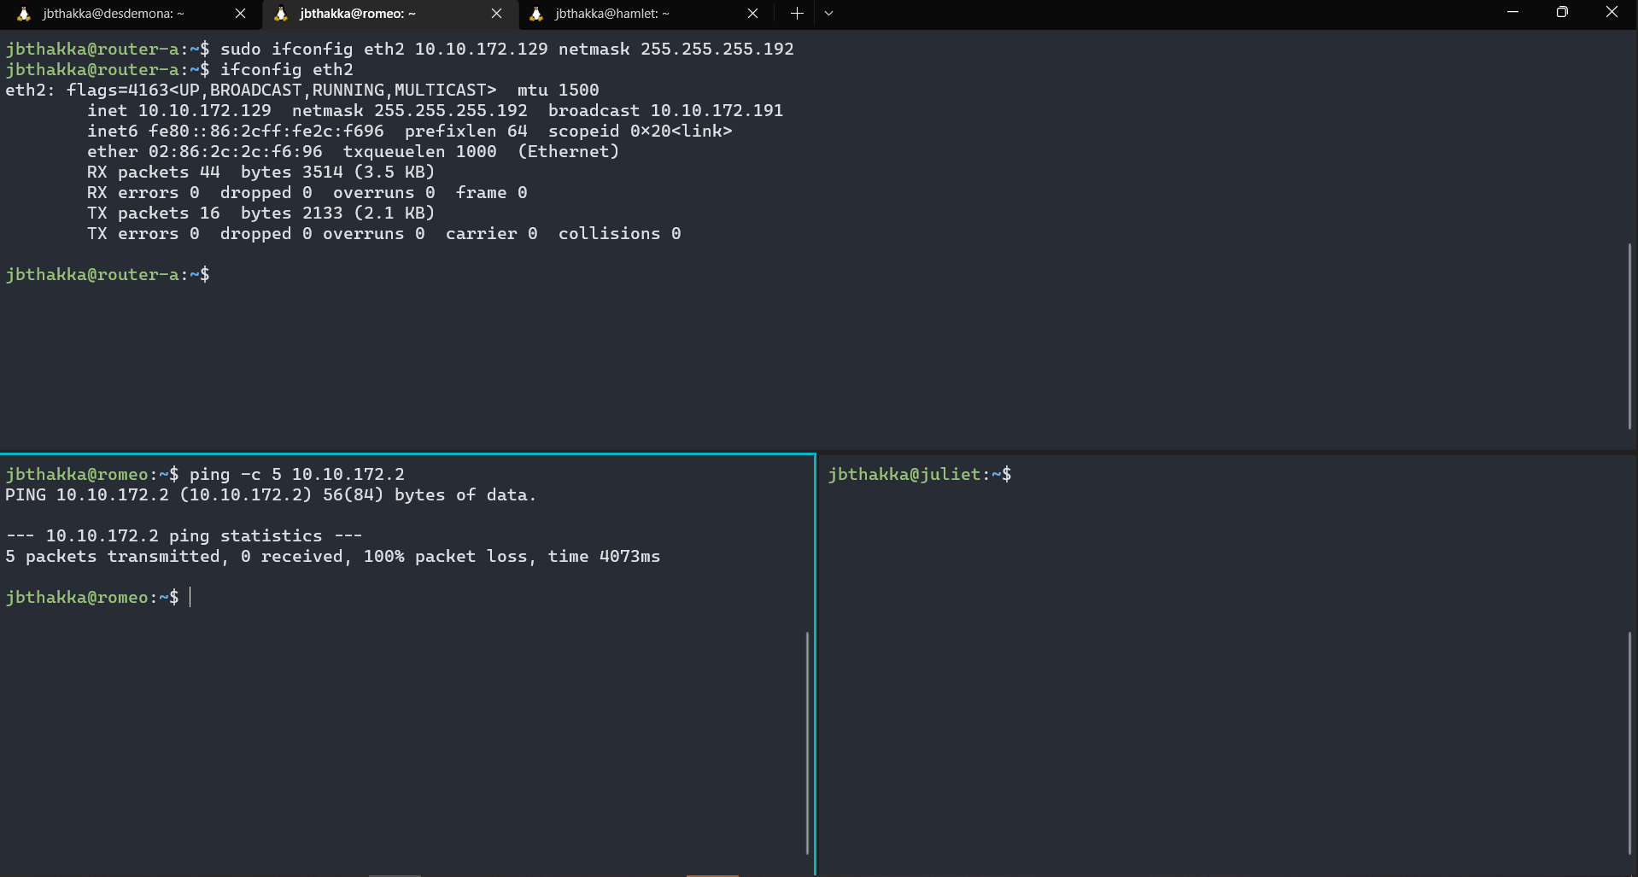

Step 2 Ping from LAN B (desdemona) To LAN C (othello):

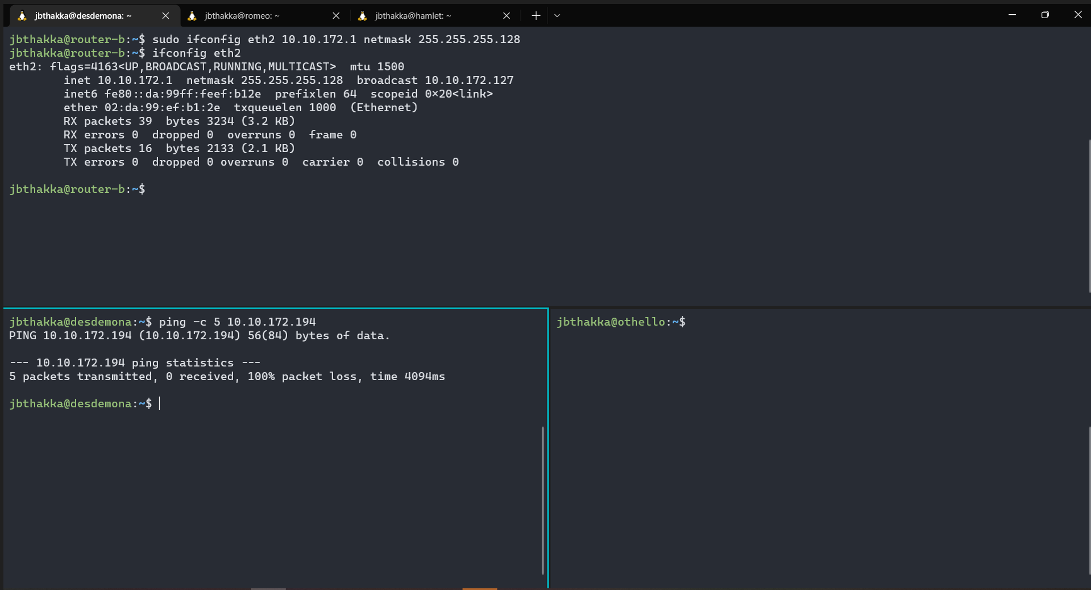

Step 2 Ping from LAN C (othello) To LAN A (romeo):

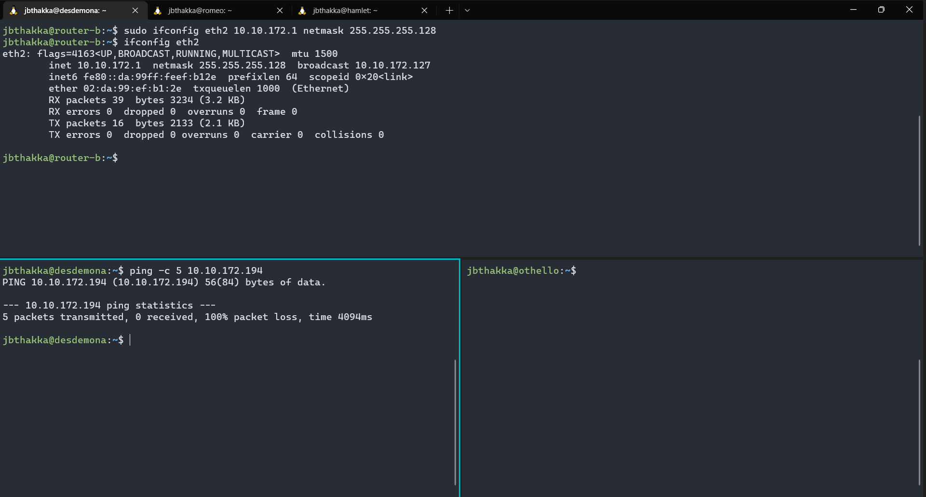

**Exercise 6**

Router-A Configuration

(Router A-B): sudo route add -net 10.10.172.0 netmask 255.255.255.128 gw 10.10.100.2

(Router A-C): sudo route add -net 10.10.172.192 netmask 255.255.255.224 gw 10.10.100.3

Host Romeo Configuration

(romeo - LAN B): sudo route add -net 10.10.172.0 netmask 255.255.255.128 gw 10.10.172.129

(romeo - LAN C): sudo route add -net 10.10.172.192 netmask 255.255.255.224 gw 10.10.172.129

Host Juliet Configuration

(juliet - LAN B): sudo route add -net 10.10.172.0 netmask 255.255.255.128 gw 10.10.172.129

(juliet - LAN C): sudo route add -net 10.10.172.192 netmask 255.255.255.224 gw 10.10.172.129

Router-B Configuration

(Router B-A): sudo route add -net 10.10.172.128 netmask 255.255.255.192 gw 10.10.100.1

(Router B-C): sudo route add -net 10.10.172.192 netmask 255.255.255.224 gw 10.10.100.3

Host othello Configuration

(desdemona - LAN A): sudo route add -net 10.10.172.128 netmask 255.255.255.192 gw 10.10.172.1

(desdemona - LAN C): sudo route add -net 10.10.172.192 netmask 255.255.255.224 gw 10.10.172.1

Host desdemona Configuration

(desdemona - LAN A): sudo route add -net 10.10.172.128 netmask 255.255.255.192 gw 10.10.172.1

(desdemona - LAN C): sudo route add -net 10.10.172.192 netmask 255.255.255.224 gw 10.10.172.1

Router-C Configuration

(Router C-A): sudo route add -net 10.10.172.128 netmask 255.255.255.192 gw 10.10.100.1

(Router C-B): sudo route add -net 10.10.172.0 netmask 255.255.255.128 gw 10.10.100.2

Host ophelia Configuration

(ophelia - LAN A): sudo route add -net 10.10.172.128 netmask 255.255.255.192 gw 10.10.172.193

(ophelia - LAN B): sudo route add -net 10.10.172.0 netmask 255.255.255.128 gw 10.10.172.193

Host hamlet Configuration

(ophelia - LAN A): sudo route add -net 10.10.172.128 netmask 255.255.255.192 gw 10.10.172.193

(ophelia - LAN B): sudo route add -net 10.10.172.0 netmask 255.255.255.128 gw 10.10.172.193

Step 1 LAN A Routing Table:

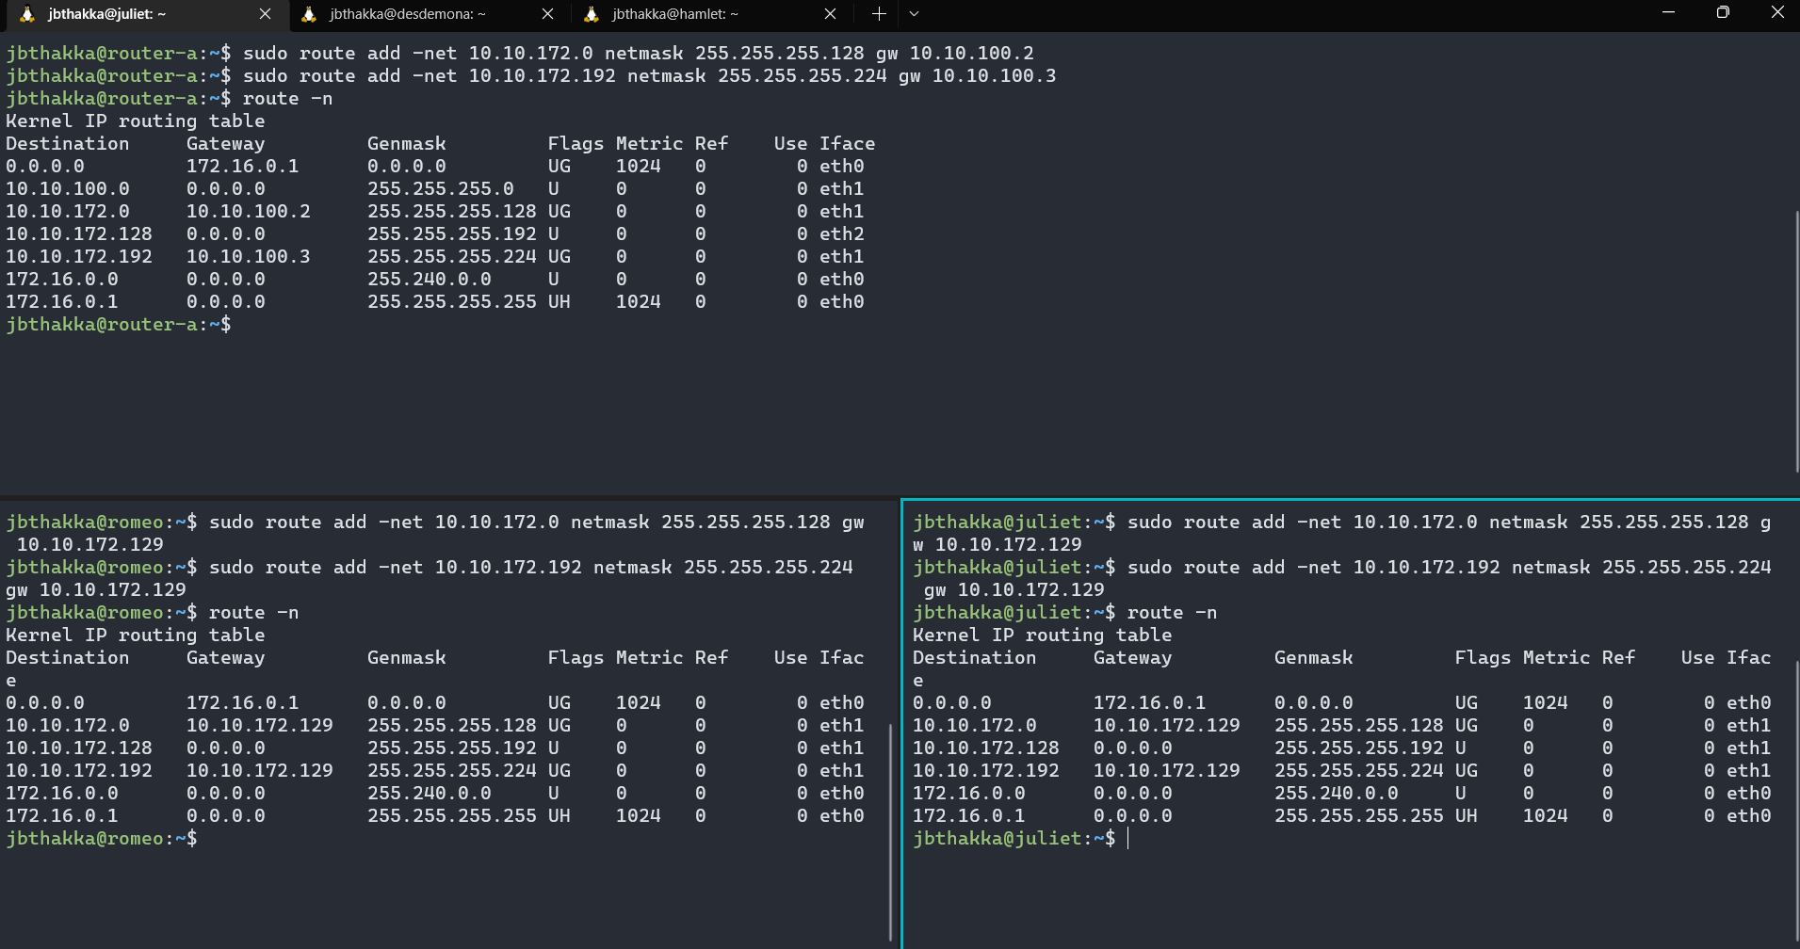

Step 1 LAN B Routing Table:

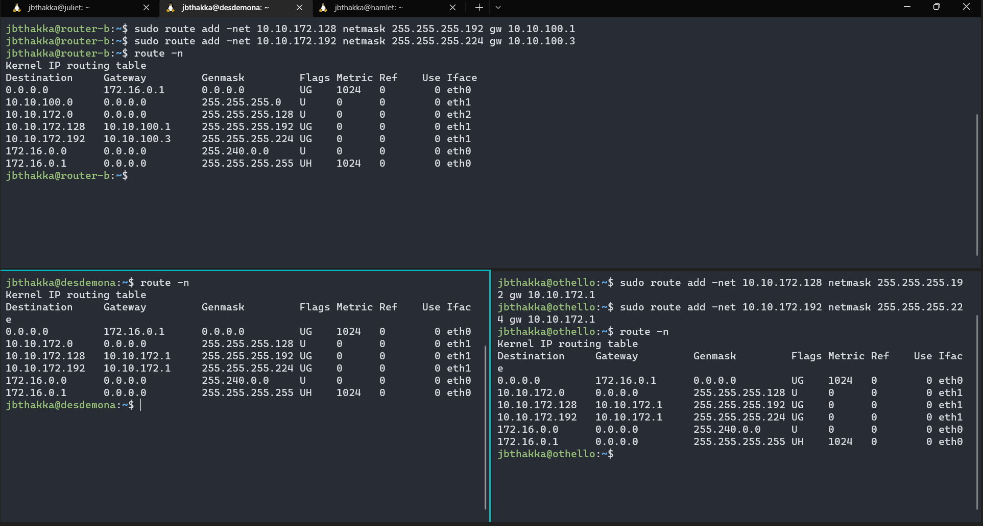

Step 1 LAN C Routing Table:

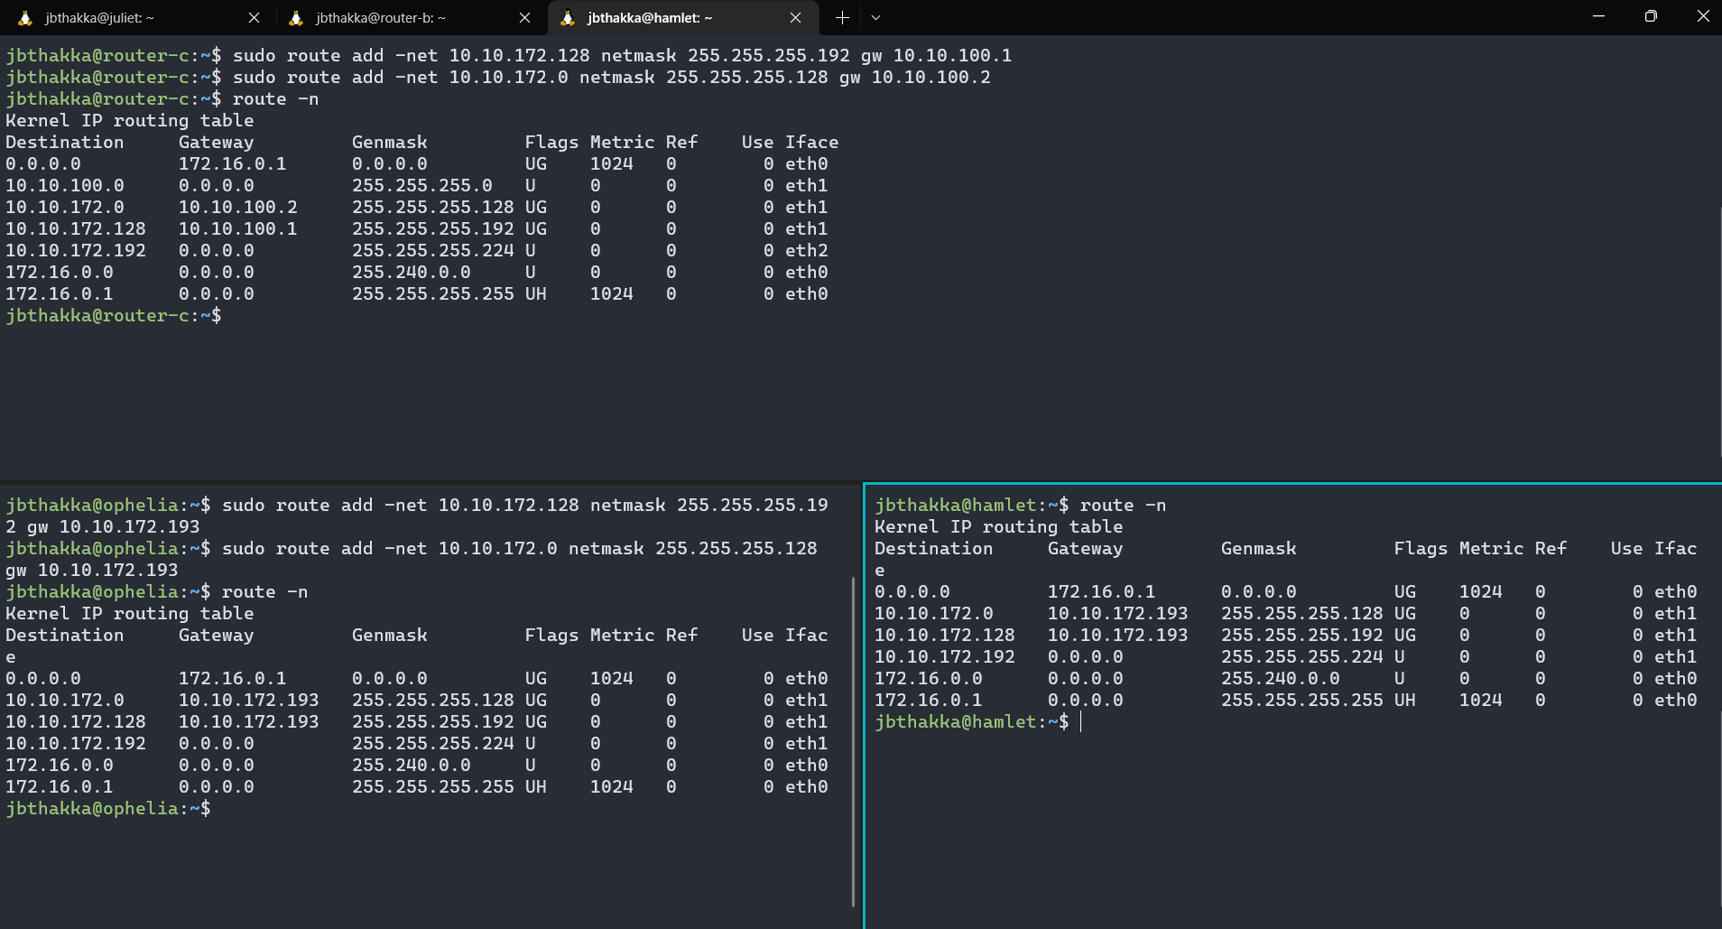

Step 2 LAN A (Ping from Host from LAN A to Host on LAN B):

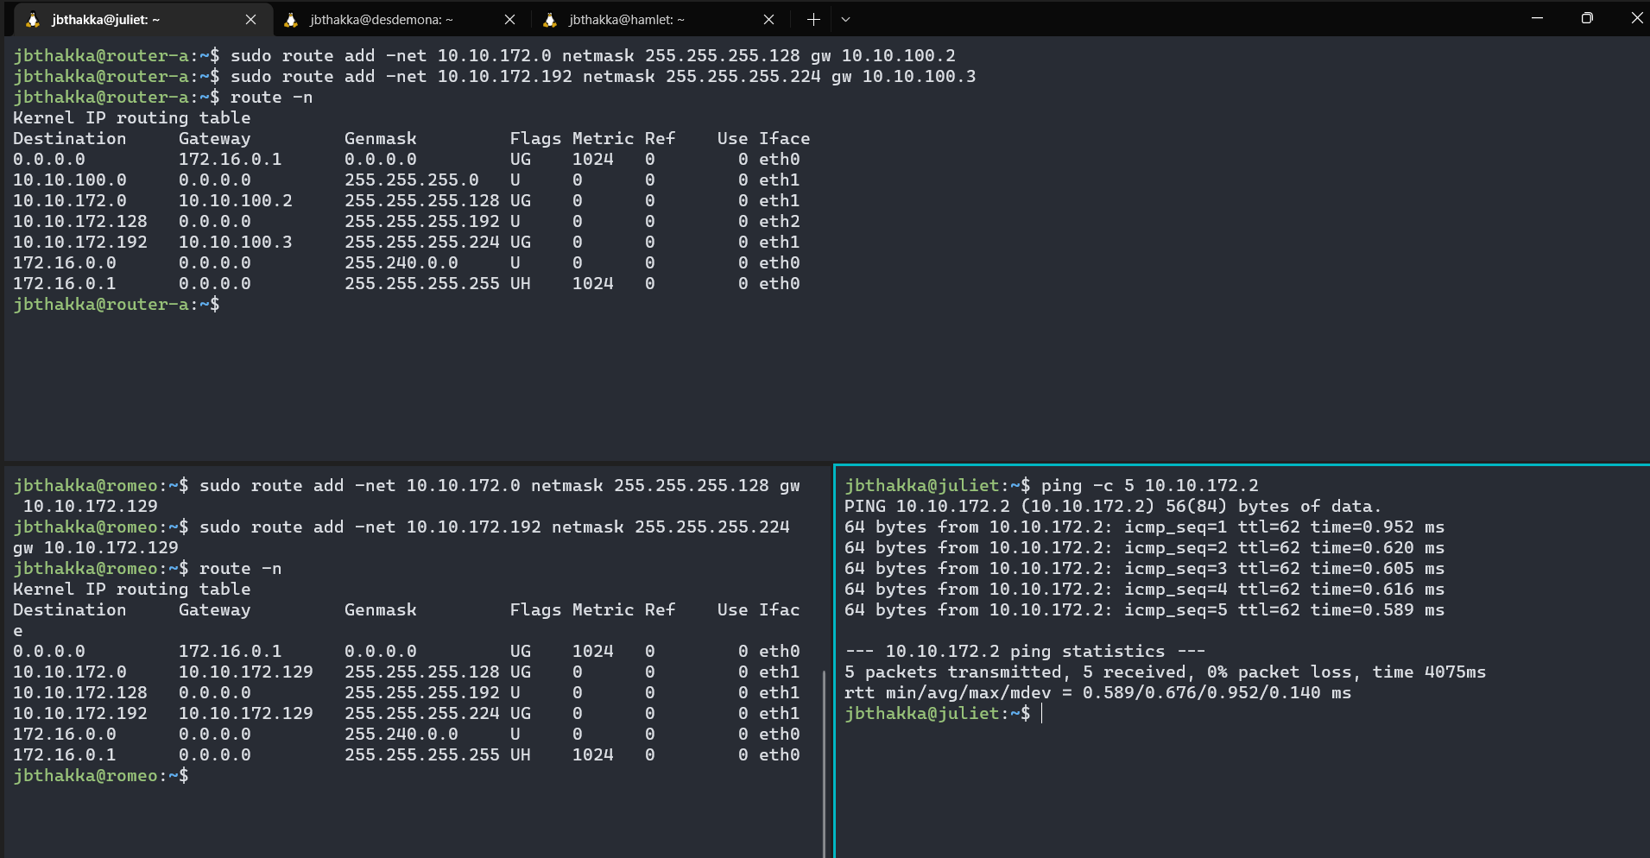

Step 2 LAN B (Ping from Host from LAN B to Host on LAN C):

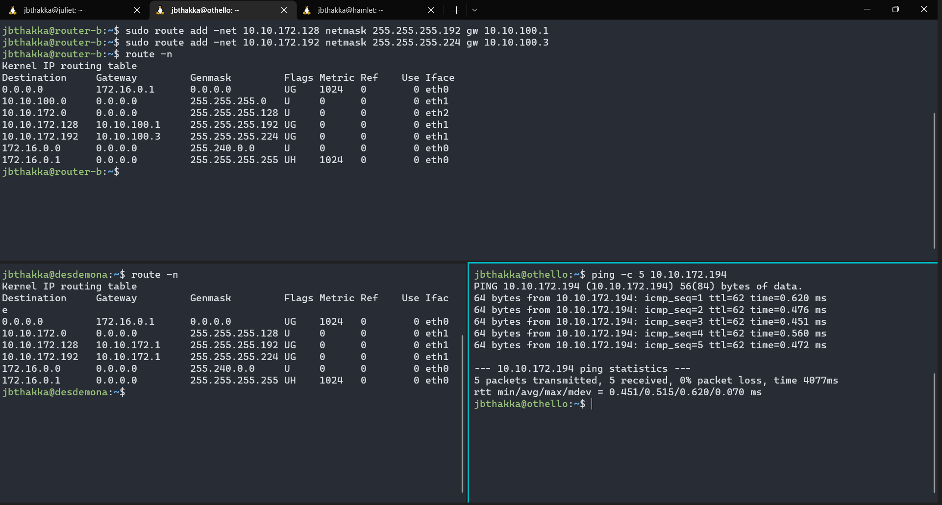

Step 2 LAN C (Ping from Host from LAN C to Host on LAN A):

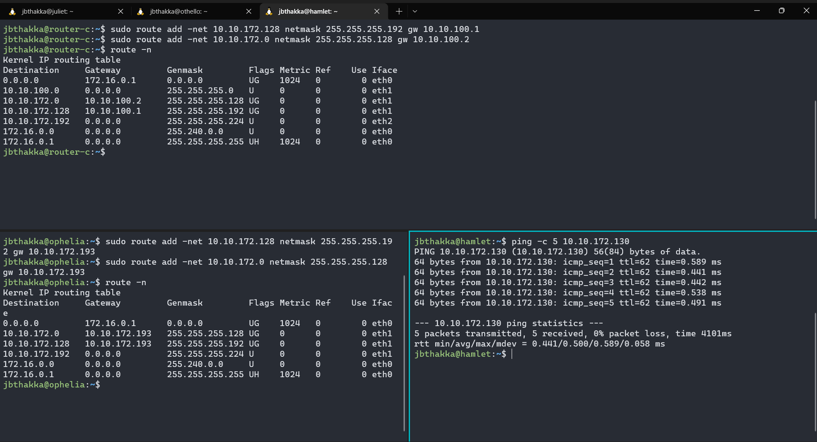

Step 3 LAN A:

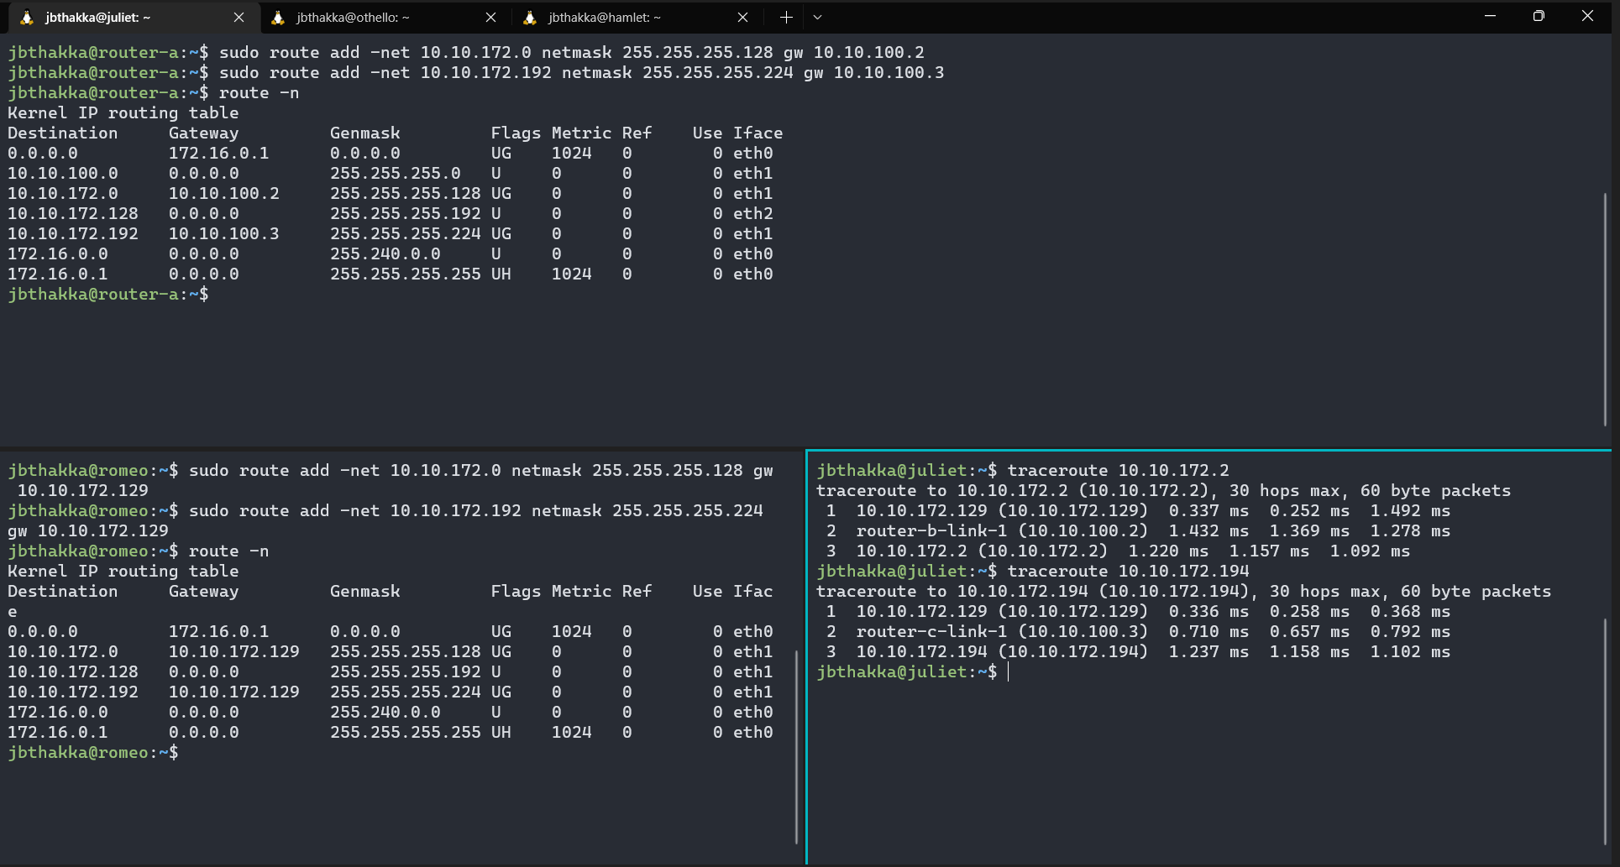

Step 3 LAN B:

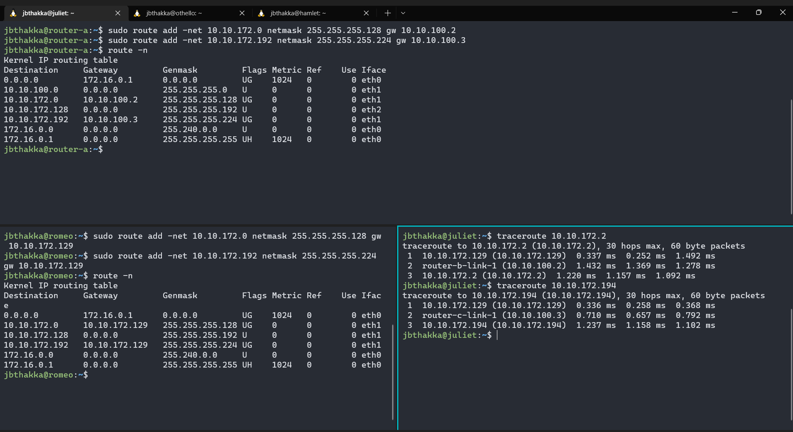

Step 3 LAN C:

